**Final Report**

Data Transmission, Lab 5

Configuring Basic Aspects of BGP Routing Protocol

Authors:

Katwikirize Emmanuel

Yusupov Yuldashbek

3A. IP ADDRESS ASSIGNMENT

The image below depicts how we configured the given subnets.  
We also configured the loopbacks as required.

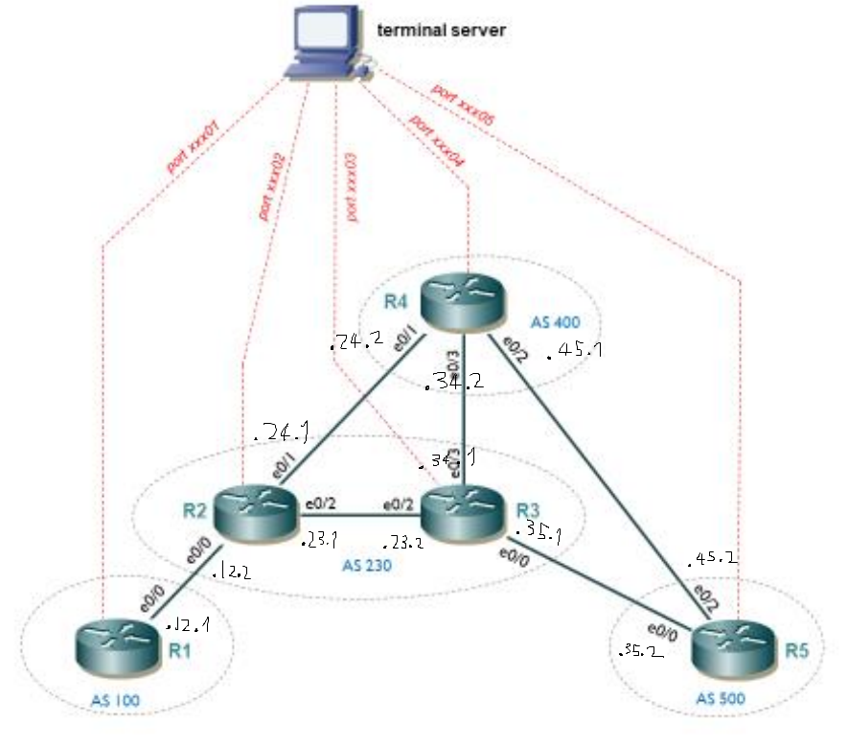

|  |  |
| --- | --- |
| Subnet | Subnet address |
| R1-R2 | 10.0.12.0/30 |
| R2-R4 | 10.0.24.0/30 |
| R3-R4 | 10.0.34.0/30 |
| R3-R5 | 10.0.35.0/30 |
| R4-R5 | 10.0.45.0/30 |
| R2-R3 | 10.0.23.0/30 |

|  |  |  |  |
| --- | --- | --- | --- |
| Router | AS | Interface | Address |
| R1 | AS100 | L0 | 1.1.1.1/32 |
|  |  | L1 | 192.168.11.1/24 |
| R4 | AS400 | L0 | 4.4.4.4/32 |
|  |  | L1 | 192.168.41.1/24 |
|  |  | L2 | 192.168.42.1/24 |
|  |  | L3 | 192.168.43.1/24 |
| R5 | AS500 | L0 | 5.5.5.5/32 |
|  |  | L1 | 192.168.51.1/24 |
|  |  | L2 | 192.168.52.1/24 |
| R2 | AS230 | L0 | 2.2.2.2/32 |
|  |  | L1 | 192.168.21.1/24 |
| R3 | AS230 | L0 | 3.3.3.3/32 |
|  |  | L1 | 192.168.31.1/24 |

3B. OSFP CONFIGURATION IN AS230

We configured OSPF on R2 – R3 link and tested it by pinging in both directions.

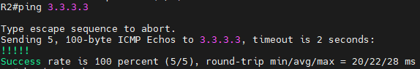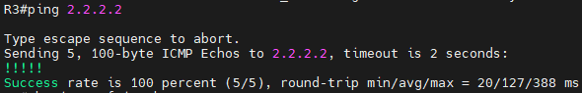

3C. BASIC BGP CONFIGURATION

1. Task C1

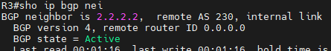

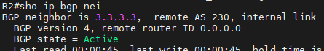

After we configured the source of BGP session, we can see that it finally became established.

s

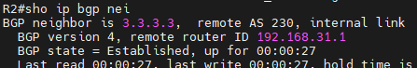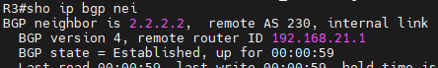

1. Task C2

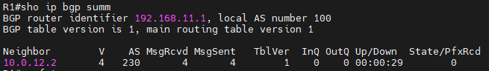

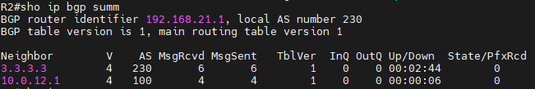

The link between R1 and R2 is established.

1. Task C3

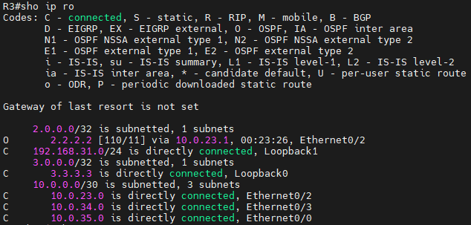

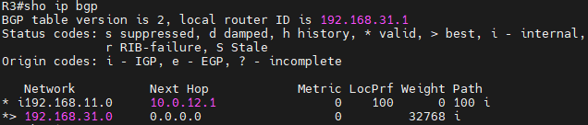

R2 advertises loopback1 of R1 to R3, but as R3 technically does not know how to reach the R1 – R2 subnet; it simply omits it from its routing table. We fix this by running “neighbor 3.3.3.3 next-hop-self” in config mode on R2 to clarify that all the networks that R2 advertises to R3 can be reached via the internal connection to R2.

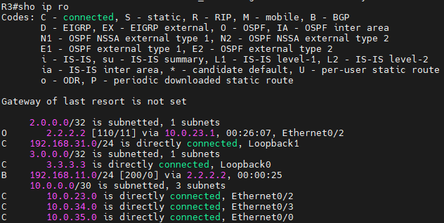

We can see now that the loopback1 network on R1 is added to the routing table of R3 and R3 now knows that it is reachable via R2.

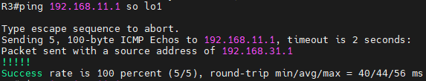

We can see that loopback1 on R1 is reachable from R3 if we specify that the source of the ping is R3’s loopback1, but if we do not then R1 wouldn’t know how to reach R3. This is because loopback0 will be used by default for the ping, but we are only using BGP and we aren’t advertising loopback0 over BGP.

We would still have the same problem if we did specify the source but still used loopback0, as in something like “ping 192.168.11.1 source lo0”.

1. Task C4

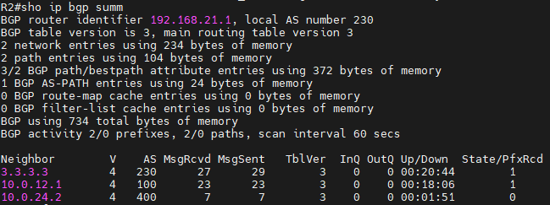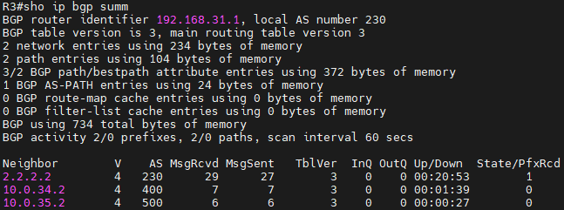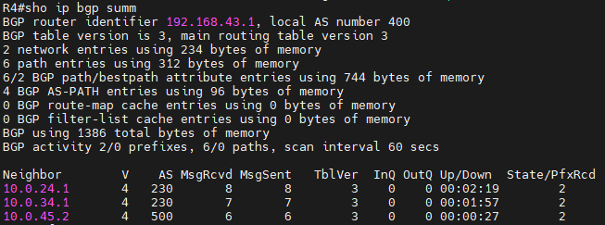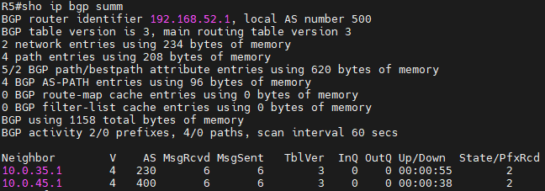

We can see that all the BGP neighbors have been configured.

1. Task C5

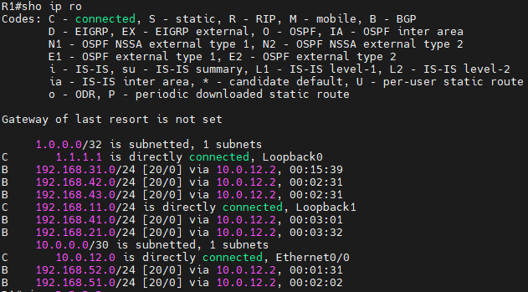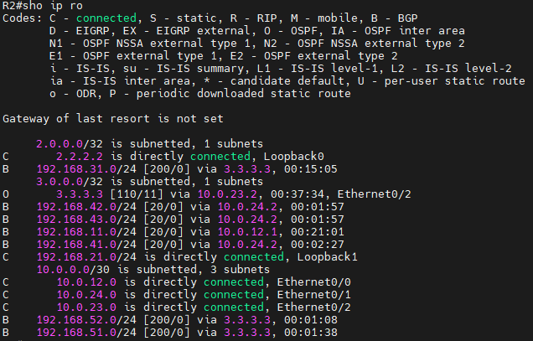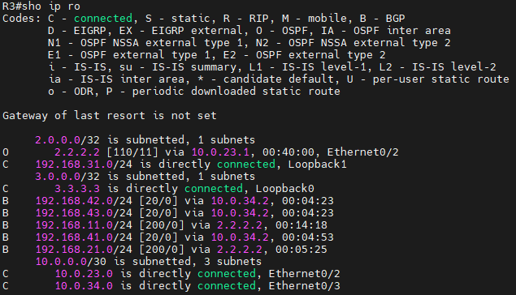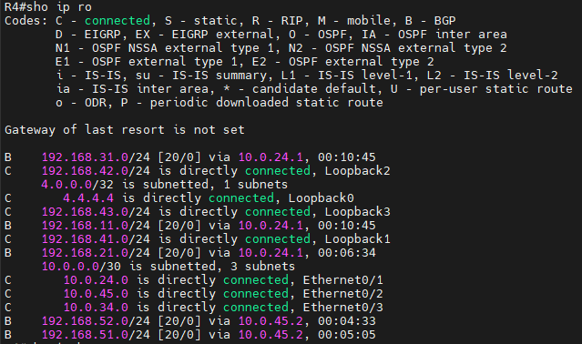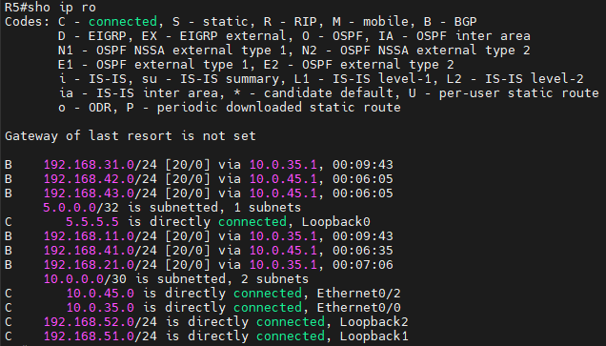

We can see that each router has every “customer network” in its routing table.

1. Task C6

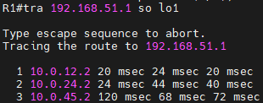

We can see that although BGP would prefer the shortest AS-path to R5, the main problem is that although R3 does advertise its connection to R5 to R2, we once again have the same problem as in Task C3 where R2 still does not know how to reach R5 through R3 because we didn’t clarify the next hop and so because R2 then omits this path from its routing table, R1 can only reach R5 through R4.

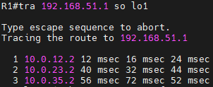

After configuring R3 to clarify to R2 that it is indeed the next hop for the networks that it advertises to R2, R2 adds the R2-R3-R5 path to its routing table. Now as we can see, BGP will prefer this one over the R2-R4-R5 one because it has a shorter AS-path (230->500->i vs 230->400->500->i respectively).

3D. ADVANCED BGP CONFIGURATION

1. Task D1

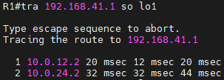

We set the local preference on R2.

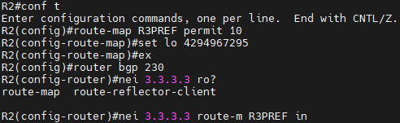  
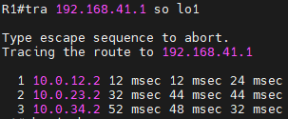

1. Task D2

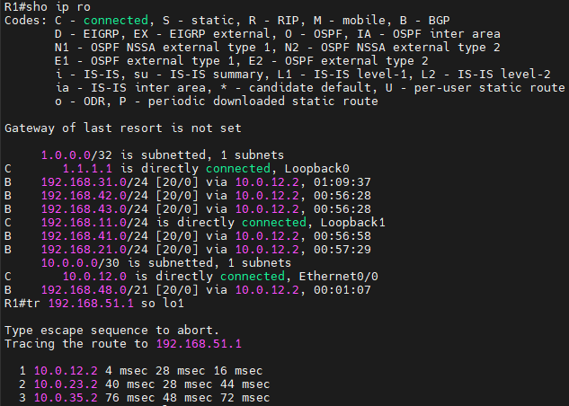

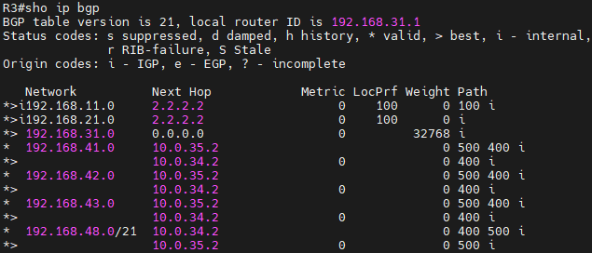

We configured R5 to aggregate its “customer network” addresses and we checked that R3 indeed has the aggregated address instead of each 192.168.5X.0/24 network, and that R1 can still reach it.

1. Task D3

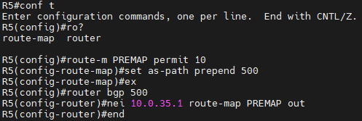  
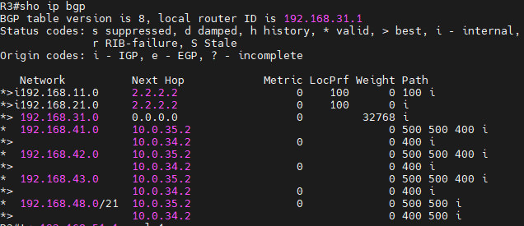

We used path prepending to artificially extend the path that R3 sees to R5, so that the BGP best path selection algorithm defaults to using the path through R4.

We can see how compared to the BGP table of R3 from Task D2, the path to 192.168.48.0/21 via 10.0.35.2 is now 500->500->i whereas is was simply 500->i before this configuration.

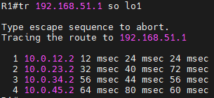

We can see from the traceroute command that the packet is now taking the path through R4 to R5.